***ASSIGNMENT OF***

***IOS DEVELOPMENT-1***

***(PART-2)***

***COURSE CODE:- MAD- 400***

***SUBMITTED TO:-MANHAR KAPOOR***

***STUDENT ID:- A00117738***

***SUBMITTED BY:- BICKY KAUR DHILLON***

**INDEX**

|  |  |  |
| --- | --- | --- |
| **SERIAL NO** | **TITLE** | **PAGE NO** |
| 1 | WHAT IS XCODE AND CAPABILITIES OF XCODE | 3 |
| 2 | HOW TO INSTALL XCODE | 3-6 |
| 3 | DIFFERENT TOOL OF XCODE | 6-7 |
| 3.1 | PROJECT VIEW | 7-8 |
| 3.2 | EDITOR AREA | 8-9 |
| 3.3 | QUICK HELP AND INSPECTORS IN XCODE | 9-11 |

**WHAT IS XCODE**

It is the integrated development environment of apple for MAC OS and it is used to develop the software for MACOS, IOS, IPADS, WATCHOS, and TVOS. It was released in the market in the year 2003 and its latest version was introduced in the market on 21 June 2021 and it is available at free of cost for the MACOS big Sur users on the MAC app store. Registered developer can download XCODE from apple developer website. It also includes the command line tool, which enable UNIX-style development via the terminal app in MACOS.



**What is xcode and its capaibities**

XCODE is also defined as a package that is known as software package and it is the combination of the programs that are interrelated in order to perform different function and these program are used by software engineer and developer in order to write software programming for MACOS, IOS devices such as IPHONE ,IPADS, apple TV and apple watch. In another words it also defined as it as integrated development environment with combination of different tools such as editors, compilers and other software that help in writing coding for different program and then these tool are used to compiling, debugging and finally it submitting it on the app store.

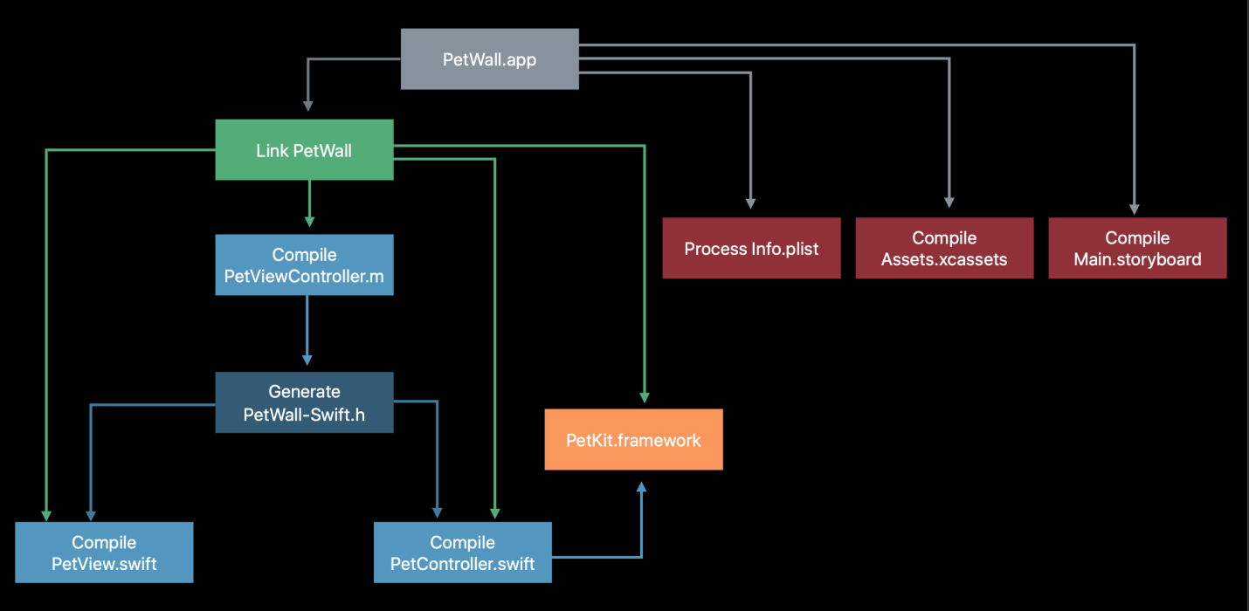

It only support to develop apps developed by apple and XCODE contain the great debugging tool kit that is immensely handy to solve the problem of the developers in very fast ways and it also have the great project management tools that are useful for organizing the different code files andimage assets andXCODE is very ideal for the beginner because it has a source code checker and it highlight the error made by developer in coding and it also provide the solution for fixing the error. It Laos have the in built snippets of the code and templates that help to make the development much smother. It also provides the viewing the multiple files at one time in XCODE editor instead of opening the multiple files. Other important feature of the XCODE is that work is done by developer is automatic saved so they do not need to worry about updates.

**HOW TO INSTALL THE XCODE**

First visit the developer website and sign in with your account id and there you will find the list of the different version of the XCODE and click on option that you want to download and downloading depend upon the speed of your internet connection and when file downloaded then extraction is done by your machine automatically and after this process drag application in your application folder and after this install the command line tool so visit the desired website and download the command line tool.dmg and install it on your machine by double clicking and this process takes only few minutes to complete. Finally open the XCODE after the installation of the all components.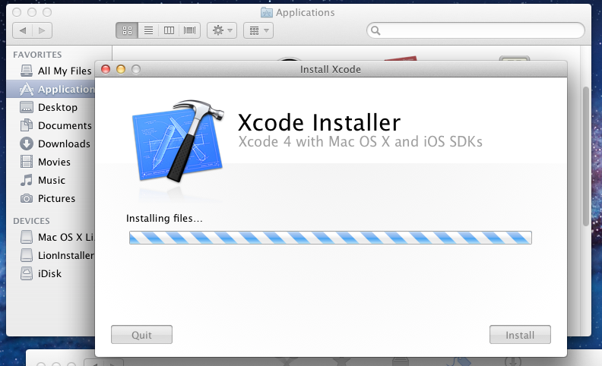

**DIFFERENT FUNCTIONALITY AND TOOLS OF THE XCODE**

**1.COLOR AND FONTS:** In order to change the font, text and background color, firstly open the XCODE and click on the app preference pane by going in the XCODE then in the preference click on the ‘fonts and color’ option and in this option there are many pre made color and font scheme are provided by XCODE and developer can use as per theirrequirements and if theywant to use the different themes like light text, dark background they do it source editor and console.

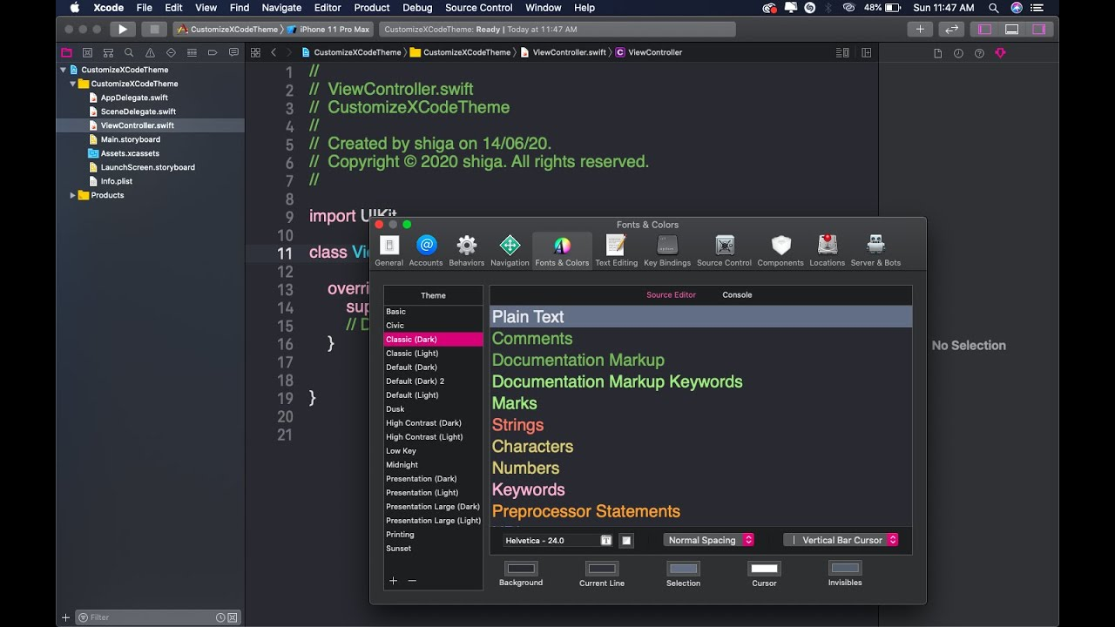

**2.TAB BAR AND TOOL BAR IN XCODE:** It is the workspace level tools that are used for managing and running the different application, viewing the progressing of the of the executing application and configuring the workspace window.tab bar have three different parts

* A flow control
* Activity viewer
* A workspace configuration

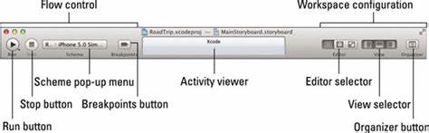

Flow control further contain the run button used for running the targets and stop button is used for terminating the executing application on devices or simulator and scheme menu and also breakpoints button that is used for activation and deactivation of the all breakpoints. The activity viewer is part of the tool bar and it is used for the viewing the progress of the project and the workspace configuration is used to point out the XCODE workspace window is match with requirement of the user project.

**3. PROJECT VIEW:** The navigator area is placed on the left side of workspace window and in order to show and hide the navigator area click on the view selector button as shown in this image and it include the navigator selector bar, the content area, and the filter bar. The main function of the project navigator to manage file in the project by using adding , deleting and other option and filter bar is used for analyzing the different files such as recently updated file, unsaved file and filenames.

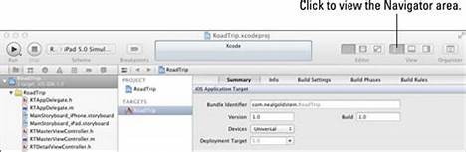

**4.EDITOR AREA CONTENT EDITORS IN XCODE:** XCODE contain the a number of editors that are for editing the content according to specification of the different project. Source editor is use for writing and editing the source code and it also help to enable and disable the breakpoints and handle the execution of the program.

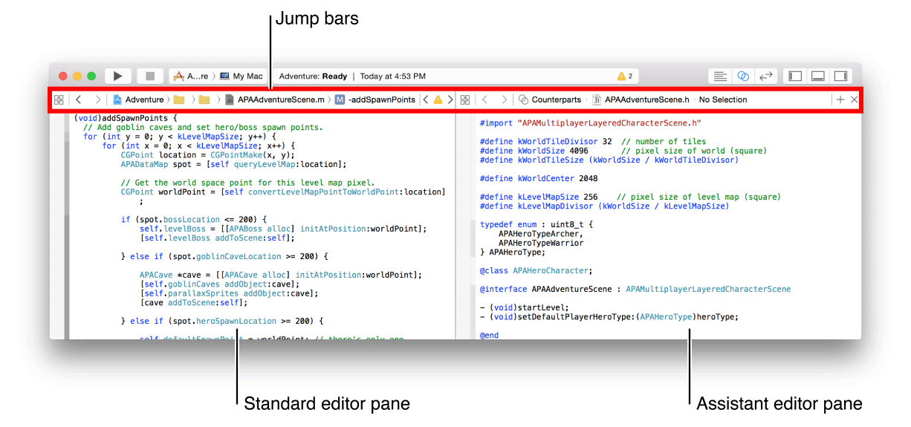

Interface builder is used for the creating and making changes in the user interface files in the story board. Mapping model editor is used editing a mapping between the old core data store and new one.

**5.QUICK HELP:** The excellent feature of the XCODE is that it can access the documentation very quickly and quick help section of the utility area provide the documentation for every symbol and it also shows a description of the symbol and some link to acquire more information about them.

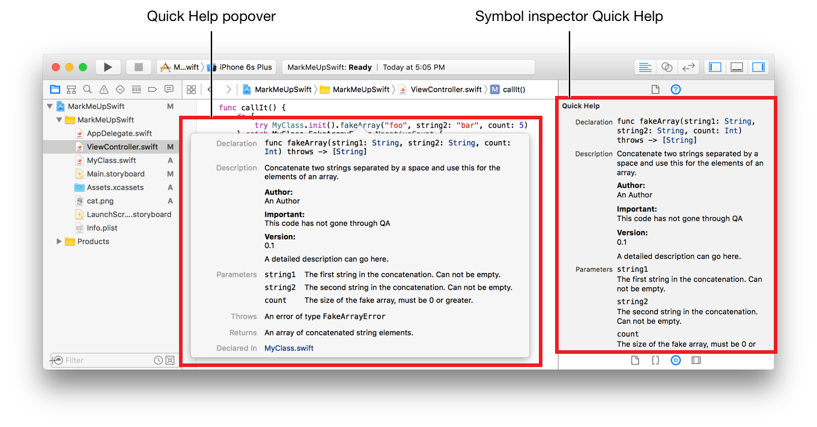

With quick help section users can get information about three type of element for the project but it depends upon the selection made by users in open editor. Symbol, in the source editor, interface objects and build setting in the interface builder and project editor. A quick help window appear with items selected by the user.

**6.INSPECTORS IN XCODE:** On right side of the workspace window in the utilities area is a inspector bar which provide the quick access to the different resources. Inspectors for viewing and making modification in different feature of the open file in editor. The top most area of the utilities display the inspector and bottom pane give the access to the library. Inspector bar contain the two type of the inspector.

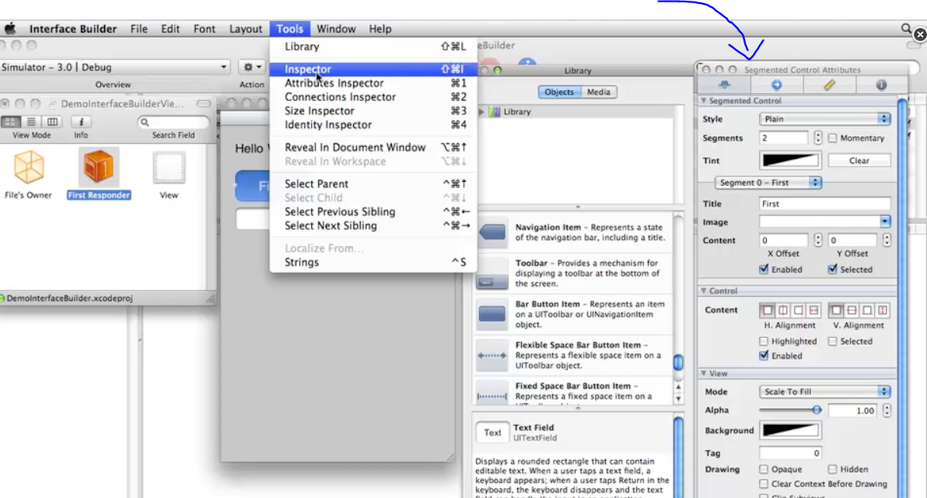

* File inspector is used for viewing and organizing the metadata of the working projects and user can adjust the setting for the user interface as per their requirements.
* Library bar contain the different resources such as file templates, code snippets, objects that is list of item for the app user interface, and media that contain the graphics, icons and sound files.

**REFEERANES:**

[**https://developer.apple.com/xcode/**](https://developer.apple.com/xcode/)

en.wikipedia.org › wiki › Xcode

www.softwaretestinghelp.com › xcode-tutorial